Notice to Members
WORKING IN THE FOLLOWING BUILDINGS
DOWNTOWN OTTAWA

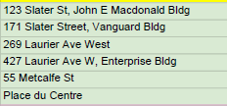

A recent report ratified by the UHEW National Council created three separate locals to represent members in the NCR working for HC, PHAC and DISC. As a result, members working in the listed building will have an Annual General Meeting scheduled once the UHEW National Office receives interest from members in running for a Local Executive position.

If you are interested in being part of a Local Executive, please email Michel Lepine, NCR UHEW Regional Vice President at Michel.lepine@uhew-stse.ca .

